# ADuCM355 Custom firmware specs

The M355 communicate with master device via UART port.

After power on, M355 will run a system diagnostic sequence.

Then it will enter the standby mode and wait for UART command.

The command and responses sent and received from M355 are JSON string. The termination of the command and response are marked by **'*'** character.

For example, the command send is {"s":1}* and the response is {"a":1}* .

**The following commands are expected and the expected response is also shown:**

|  |  |  |
| --- | --- | --- |
| Command | Response | Description |
| {“s”:1}* | {“a”:1}* | Check communication |
| {“v”:1}* | {“v”:”2.2.0”}* | Firmware version |
| {“vS”:-600,  “vE”:0,  “vI”:5,  “vA”:100,  “Hz”:100,  “iS”:100,  “ps”:0,  “vP”: -600,  “ch”:0,  “f”:0,  “r”:0}* | {  “c”:[  1.123,  2.321,  4.414,  3.123,  …]  }* | Run SWV scan with the give parameters, and return the scanning results.  The current returned can be positive or negative.  See the details below. |

vS: scanning start potential

vE: scanning ending potential

vI: scanning step voltage increment

vA: scanning voltage amplitude

Hz: scanning frequency

iS: expected scanning current scale in uA

ps: potentiostat to use (can be 0 or 1)

vP: pre-treatment potential (this is usually the same as vS)

ch: scanning channel (can be 0 – 3). The channel number will determine the channel selection GPIO state and control the channel selection on the two MUX.

f and r: the flag to indicate whether forward and reverse current are returned respectively. Use 0 to indicate no return. If f or r is set to 1, the Repsonse data will have additional “f”:[-1.123,-3.4123,…] and “r”:[3.123,…] array.

The parameters to send for each scan need to be adjusted based the previous scans or the current application we are using.

The most frequently used changes are the vS and vE.

The starting and ending potential need to be adjusted so that the scanning range cover the peak range. See figure below. The scan range for this scan is adjusted to vS = -0.35 and vE=0.15 (roughly)

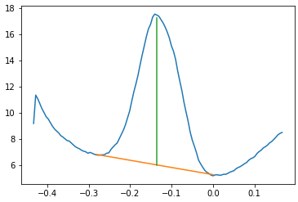

The peaking fitting should happen during the scan and find the peak potential, then use this value to determine the scanning start and end potential for the next scan.